Contents

1. Introduction 3
2. DELTA Evaluation 3
   1. Data (4/5) 3
   2. Enterprise (3.5/5) 4
   3. Leadership (3/5) 4
   4. Targets (4/5) 5
   5. Analysts (3.5/5) 5
3. Proposed Analytics Project 6
4. Two Thematic Analyses (Understanding Stakeholders and Communicating to different audience) 7
   1. Theme 1: Understanding Stakeholders 7
   2. Theme 2: Communicating to Different Audiences 9
5. Conclusion 11
6. References 11

# Introduction

Strava, a fitness tracking and social networking platform, has revolutionized how athletes and fitness enthusiasts track their activities, analyze performance, and connect with like-minded individuals. With over 100 million users globally (Strava, 2023), Strava collects and analyzes vast amounts of data, including GPS routes, activity metrics, and social interactions, making it a key player in fitness analytics.

The company’s mission revolves around building a community of athletes, leveraging data to provide personalized fitness insights and encourage active participation(Strava, 2023). Analytics plays a central role in Strava’s operations, from improving user experience to driving revenue through premium subscriptions and partnerships (Davenport and Harris, 2007).

This report evaluates Strava’s analytics maturity using the DELTA framework, identifying areas of strength and opportunities for improvement. It proposes a predictive engagement model as a new analytics project to enhance user retention and engagement. Furthermore, it explores two course themes—understanding stakeholders and communicating to different audiences—to develop actionable recommendations for integrating analytics into Strava’s operations.

# DELTA Evaluation

DELTA Framework introduced by (Davenport and Harris, 2007), helps us to assess the analytical capabilities of a company. What DELTA stands for is written below.

1. Data
2. Enterprise
3. Leadership
4. Target
5. Analysts

Let us look at the delta scoring for STRAVA.

## Data (4/5)

Strava's primary strength lies in its comprehensive data collection. The platform captures high- quality structured data, including GPS coordinates, time, elevation, and speed, as well as unstructured data, such as user comments and uploaded photos (Strava, 2023). The seamless

integration with devices like Garmin, Apple Watch, and Fitbit ensures data accessibility across multiple platforms (Fitbit Blog, 2022).

Despite these strengths, challenges persist in ensuring data quality, especially with user- uploaded information. For example, inconsistencies in manually entered data, such as incorrect activity types, can impact the accuracy of insights (Mitchell, 1997). Strava also faces difficulties in incorporating external unstructured data, such as social media trends, to enrich its analytics (Few, 2012).

### Key Improvement Areas:

* + - Develop automated quality checks for user-entered data.
    - Integrate external data sources to enhance trend analysis and personalization.

## Enterprise (3.5/5)

Analytics is deeply embedded in Strava's strategic goals, such as boosting premium memberships and fostering community engagement (Strava, 2023). Data-driven initiatives like personalized leaderboards and group challenges highlight its commitment to analytics.

However, cross-departmental integration is inconsistent.

While the product development team effectively uses analytics to enhance user features, the marketing and customer support teams show limited adoption of insights in decision-making (Davenport and Harris, 2007). Additionally, there is scope to align analytics projects with broader organizational objectives.

### Key Improvement Areas:

* + - Establish a centralized analytics team to coordinate efforts across departments.
    - Conduct workshops to educate all teams on the strategic use of analytics.

## Leadership (3/5)

Strava’s leadership supports data-driven decision-making, particularly in developing new features and forging partnerships (Norman, 2013). However, leadership advocacy for a company-wide analytics culture is inconsistent. For example, while leadership prioritizes user engagement metrics, other departments may not receive the same level of focus.

### Key Improvement Areas:

* + - Promote an analytics-driven culture through leadership-led initiatives, such as town halls or workshops.
    - Introduce performance indicators to assess and reward analytics adoption across teams.

## Targets (4/5)

Strava sets clear, measurable targets, including increasing monthly active users and premium subscriptions (Strava, 2023). Analytics plays a critical role in tracking these goals through metrics like user retention rates and community engagement. However, the absence of granular KPIs for specific initiatives limits its ability to evaluate project success comprehensively(Davenport and Harris, 2007).

### Key Improvement Areas:

* + - Develop detailed KPIs for specific analytics projects, such as measuring the success of group challenges or new feature rollouts.
    - Implement a dashboard for real-time tracking of these KPIs.

## Analysts (3.5/5)

Strava’s analytics team is proficient in handling complex datasets and delivering actionable insights. However, collaboration between analysts and other teams is limited, reducing the overall impact of analytics on decision-making (Provost and Fawcett, 2013).

### Key Improvement Areas:

* + - Foster cross-functional collaboration by embedding analysts within teams like marketing and customer support.
    - Provide training for non-technical staff to interpret and use analytics outputs effectively (Heath and Heath, 2007).

|  |  |
| --- | --- |
| DELTA Parameters | Score |
| Data | 4 |
| Enterprise | 3.5 |
| Leaderships | 3 |
| Targets | 4 |
| Analyst | 3.5 |

Total **DELTA** Score for STRAVA is **3.6/5.**

Strava demonstrates moderate analytics maturity. Key areas for improvement include



*Figure 1 DELTA dashboard for Strava*

enhancing cross-departmental collaboration, promoting leadership-driven analytics culture, and developing granular KPIs to refine project-level success tracking.

## Proposed Analytics Project

**Project Title:** Predictive Engagement Model for Group Challenges

Strava’s group challenges are an effective way to boost user engagement and foster community. However, participation rates could be improved by leveraging predictive analytics to recommend challenges tailored to user preferences and activity history (Mitchell, 1997).

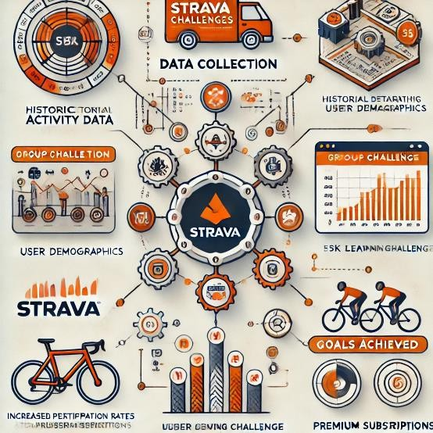The proposed project involves creating a machine learning model to analyze historical activity data, user demographics, and engagement patterns (Provost and Fawcett, 2013).

*Figure 2 Predictive Engagement Model for Strava*

The model will predict the likelihood of users joining specific challenges and recommend personalized options. For example, a user who frequently runs short distances could receive a recommendation for a 5K group challenge.

The project aims to increase participation rates by 20%, enhance user retention, and drive premium subscriptions (Strava, 2023). It will also provide valuable insights into user behavior, enabling Strava to refine its offerings further.

# Two Thematic Analyses (Understanding Stakeholders and Communicating to different audience)

## Theme 1: Understanding Stakeholders

Strava operates within a diverse and complex ecosystem of stakeholders, each with unique needs and expectations regarding the platform's analytics capabilities. As emphasized by Freeman (1984), understanding stakeholders is crucial for aligning analytics initiatives with organizational objectives and delivering value to all parties. Strava’s stakeholders can be broadly categorized into three groups: primary users, business partners, and internal teams. Primary users include casual fitness enthusiasts, professional athletes, and social groups, all of whom rely on Strava for personalized insights, progress tracking, and engaging challenges.

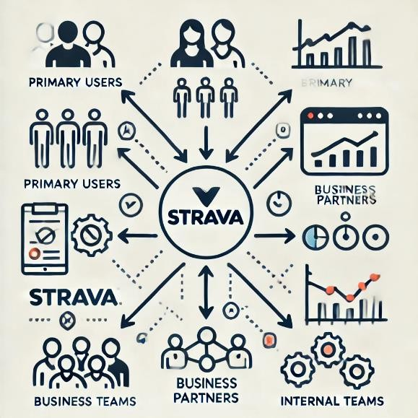

*Figure 3 Stakeholder Ecosystem*

For example, a marathon runner may require advanced analytics to monitor pace and elevation, while a casual cyclist might value simplified progress updates. Business partners, such as brands, event organizers, and sponsors, use Strava’s platform to conduct targeted marketing and make data-driven decisions. Their needs revolve around ROI analysis, user demographic insights, and engagement metrics for their campaigns. Finally, Strava’s internal teams, including product development, marketing, and customer support, depend on analytics for designing features, executing campaigns, and enhancing user engagement.

To address stakeholder needs effectively, Strava must tackle specific challenges. Primary users present diverse requirements, necessitating a balance between offering advanced features for athletes and simplicity for casual users. Solutions include the implementation of machine learning models to provide customized recommendations based on user behavior and real-time feedback through dynamic visuals such as heatmaps and route efficiency graphs. Business partners face the challenge of maintaining data privacy while obtaining actionable insights.

Strava can mitigate this by developing custom dashboards to display aggregate data on demographics, trends, and campaign ROI, alongside offering predictive analytics to forecast trends like event participation rates. Internal teams often lack direct access to analytics tools or the skills to interpret data effectively. To overcome this, Strava should provide workshops on data interpretation for non-technical staff and embed analysts within cross-functional teams to ensure the timely delivery of relevant insights.

Opportunities for improvement in Strava’s stakeholder management include the establishment of regular feedback loops to better understand stakeholder expectations.

User surveys, for instance, can help refine analytics tools, while partner feedback can guide the

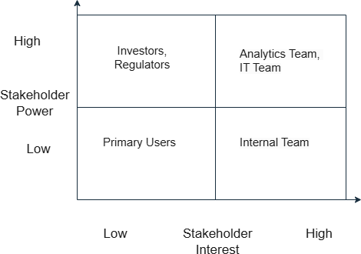

*Figure 4 Power Grid Stakeholders*

development of more effective dashboards. Deploying real-time analytics for users and partners could also enhance engagement by offering live tracking of challenge participation rates.

Collaborative development processes, where stakeholders are actively involved in designing new tools, can further ensure that their needs are met.

To capitalize on these opportunities, Strava should create segmented dashboards tailored to each stakeholder group. For primary users, these dashboards could include progress metrics and challenge recommendations, while partners might benefit from campaign performance metrics and demographic insights. Internal teams could use dashboards that provide data on feature usage and campaign outcomes. Involving stakeholders in the design phase of analytics tools will also align outputs with their needs, while educational initiatives such as tutorials and webinars can help users and partners better utilize Strava’s analytics capabilities.

## Theme 2: Communicating to Different Audiences

Effective communication of analytics insights is essential for ensuring that data-driven decisions are both understood and actionable across Strava’s diverse audience base. Heath and Heath (2007) highlight that tailored communication strategies can enhance engagement and support the successful adoption of analytics-driven initiatives. Strava’s audiences include primary users, leadership, and technical teams, each requiring unique communication approaches.

Primary users, who often lack technical expertise, need data presented in an intuitive and engaging manner. To meet this requirement, Strava can use visual tools such as charts, graphs, and heatmaps to make insights easily digestible. Weekly activity summaries highlighting progress indicators—like miles covered or elevation climbed—can further engage users.

Leadership, on the other hand, focuses on strategic decisions and requires high-level summaries rather than technical details. Strava can address this by developing executive dashboards that emphasize key performance indicators (KPIs) such as retention rates and revenue growth. Quarterly briefings, supported by visually appealing presentations, can summarize analytics outcomes and align them with business goals. For technical teams, granular data and detailed methodologies are essential to refining algorithms and enhancing features. Sharing detailed reports with datasets and model performance metrics, alongside using collaboration tools like Slack or Jira, can streamline communication within these teams. Strava can enhance communication by adopting specific channels for each audience.

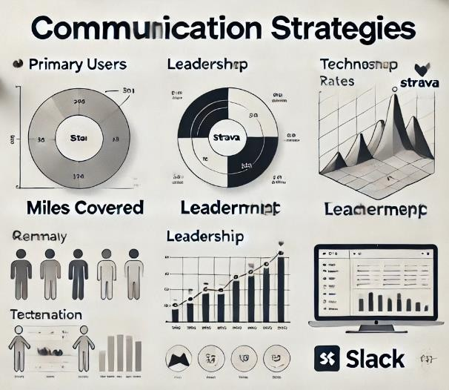

*Figure 5 Communication Strategies*

Email digests summarizing weekly performance metrics can engage users, providing them with actionable insights in a convenient format. Leadership can benefit from quarterly presentations that focus on strategic metrics and their alignment with broader objectives. Bi-weekly cross- functional meetings can ensure that internal teams remain aligned on analytics-driven strategies, while webinars and tutorials can educate users and partners on new features or analytics tools. For instance, a webinar on analyzing running progress using Strava’s dashboards could significantly improve user engagement.

To improve communication, Strava should establish standardized protocols to ensure consistency in messaging across all teams and audiences. For users, casual and motivational language can make insights more relatable, while leadership requires concise and strategic summaries. Technical teams, conversely, need detailed and precise communication. Investing in robust reporting tools like Tableau or Power BI can further streamline the generation of dynamic reports tailored to each audience. Developing audience personas, such as a casual runner seeking basic summaries or a sponsor requiring ROI metrics, can also guide communication strategies. Lastly, regular feedback loops through surveys and focus groups can help Strava refine its communication strategies and identify what resonates most with each audience.

By understanding stakeholders and tailoring communication strategies to their unique needs, Strava can effectively leverage analytics to enhance user engagement, strengthen partnerships, and drive strategic goals. These thematic approaches ensure that analytics insights not only align with stakeholder expectations but also empower all groups to make data-driven decisions.

# Conclusion

Strava stands as a leader in the fitness tracking industry, with robust analytics capabilities that have been integral to its growth and user engagement. The DELTA framework evaluation highlights Strava's strengths, including comprehensive data collection, integration with third- party devices, and clear organizational targets such as increasing premium memberships and fostering community engagement (Davenport and Harris, 2007). However, the analysis also uncovers key areas for improvement: enhancing cross-departmental analytics integration, promoting a company-wide analytics culture through leadership, and fostering collaboration between analysts and non-technical teams.

The proposed **Predictive Engagement Model for Group Challenges** is a practical step forward to address some of these gaps. By leveraging machine learning to recommend personalized challenges, this project can boost user engagement by 20%, enhance retention, and drive premium subscriptions. Moreover, the project aligns with Strava’s strategic goals while addressing stakeholder needs.

Thematic analyses of **Understanding Stakeholders** and **Communicating to Different Audiences** offer actionable insights to refine analytics initiatives. Tailored communication strategies and stakeholder-specific dashboards can bridge gaps between analytics outputs and actionable decisions, ensuring every group derives value.

Moving forward, Strava must invest in refining its analytics maturity by embedding a data-driven culture, fostering cross-functional collaboration, and prioritizing user-centric innovation. These measures will enable Strava to maintain its competitive edge and foster deeper connections within its global fitness community.

# References

Davenport, T. H. and Harris, J. G. (2007). *Competing on Analytics: The New Science of Winning*. Boston: Harvard Business School Press.

Evergreen, S. D. H. (2017). *Effective Data Visualization: The Right Chart for the Right Data*. London: SAGE Publications.

Few, S. (2012). *Show Me the Numbers: Designing Tables and Graphs to Enlighten*.

Burlingame, CA: Analytics Press.

Fitbit Blog (2022). *Using Data to Drive Engagement in Health and Fitness Applications*. Available at: [https://blog.fitbit.com](https://blog.fitbit.com/) (Accessed: 23 January 2025).

Freeman, R. E. (1984). *Strategic Management: A Stakeholder Approach*. Cambridge: Cambridge University Press.

Heath, C. and Heath, D. (2007). *Made to Stick: Why Some Ideas Survive and Others Die*. New York: Random House.

Mitchell, T. M. (1997). *Machine Learning*. New York: McGraw-Hill.

Nielsen, J. (2005). *User-Centered Design and Usability Testing in Software Development*. New York: Wiley.

Norman, D. A. (2013). *The Design of Everyday Things*. New York: Basic Books.

Provost, F. and Fawcett, T. (2013). *Data Science for Business: What You Need to Know About Data Mining and Data-Analytic Thinking*. Sebastopol, CA: O'Reilly Media.

Strava (2023). *Annual Report*. Available at: [https://www.strava.com](https://www.strava.com/) (Accessed: 23 January 2025).